The Beat of Nightbheat
A soft landing in dreamland
Companion note to the overnight tone script

Visualization — frequency and amplitude over time
The plot below shows what the script does over one 90-minute run. The line traces the instantaneous frequency over time, and its thickness encodes the amplitude (thick = louder, thin = quieter). Time runs on a logarithmic axis so the very first inner cycles are visible alongside the full schedule.
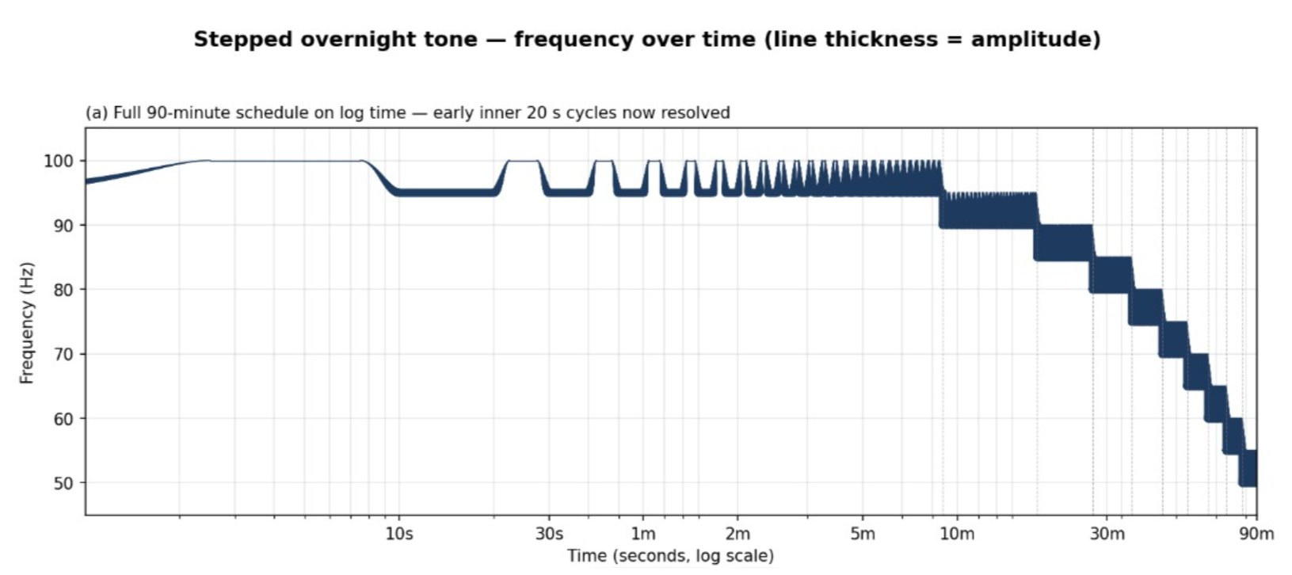

Reading the plot
- Frequency and amplitude oscillate together in a 20-second period — that’s 3 cycles per minute. Resonance breathing sits around 5 breaths per minute, so 3 per minute is deliberately slower: a target that nudges breathing downward to make reaching resonance feel easy rather than effortful.
- The carrier frequency steps down under programmatic control every 9 minutes. The 20-second oscillation continues throughout, but it gradually fades as the steps descend, because the speaker becomes progressively less efficient at producing lower frequencies.
- Eventually the signal fades into the noise floor as the speaker reaches its low-frequency limit near 50 Hz. By that point most listeners are well asleep, and the slow disappearance of the tone has a quality of letting go rather than being switched off.
The combined effect, at least subjectively, is something close to a soft landing in dreamland.

If you’re adventurous and want to build your own version
Below is the Python that produces the above when run on Windows. It streams audio in real time through your default sound device using sounddevice + numpy. No file is written; the tone is generated and played as it goes.

What you’ll need
- Python 3 (installed via the Python install manager from python.org; the launcher command is py).
- Two libraries: install with py -m pip install sounddevice numpy.
- A speaker that can reach down to the bottom of the schedule. Laptop speakers usually can’t. An external JBL or similar driven from the headphone jack works well.
- A sensible sleep setting in Windows. Set Settings → System → Power & battery → Screen and sleep to Never while plugged in, otherwise the audio stream stops when the screen sleeps.

Running it
Save the script (next page) as something like nightbheat.py and run it from a fresh terminal window:
py nightbheat.py
The script prints the full schedule on startup so you can see where it’s headed, then streams. Press Ctrl+C to stop early. When the 90-minute schedule completes, the script exits on its own.

Tweaking it
All the knobs live in the parameter block at the top of the script. The ones most worth playing with:
- START_PEAK / START_BASE / STEP_HZ / NUM_STEPS — the high end, low end, step size, and number of 9-minute steps.
- BASE_AMP / PEAK_AMP — amplitude at the low and high frequencies of each step. Keep peak well below 1.0 to avoid clipping.
- CYCLE_SEC / DUTY / RISE_FRAC / PLATEAU_FRAC / FALL_FRAC — the shape of the inner 20-second cycle. Change CYCLE_SEC if you want a faster or slower pacing target.

The script
Save as nightbheat.py. The script is self-contained — it only needs sounddevice and numpy installed in your Python environment.
#!/usr/bin/env python3
"""
Overnight breathing/coupling tone with stepped descending frequency band.

Inner cycle (20s): single continuous tone glides from BASE up to PEAK and back,
using a cos^2 rise / flat plateau / cos^2 fall shape. Amplitude tracks
frequency to compensate for speaker frequency response.

Outer schedule: every 9 minutes, the (BASE, PEAK) pair drops by 5 Hz.
Starts at (95, 100), ends at (50, 55), then the script stops.

Phase is continuously integrated across both timescales, so there are no
discontinuities at any boundary.

Stop early with Ctrl+C.
"""
import numpy as np
import sounddevice as sd
import sys

# -------- Parameters --------
SAMPLE_RATE = 44100 # Hz

# Outer schedule
START_PEAK = 100.0 # Hz, highest frequency of step 1
START_BASE = 95.0 # Hz, lowest frequency of step 1
STEP_HZ = 5.0 # Hz drop per step
STEP_SEC = 9 * 60 # 9 minutes per step
NUM_STEPS = 10 # 100/95 down to 55/50

# Inner cycle (within each step)
CYCLE_SEC = 20.0 # full inner cycle period
DUTY = 0.50 # fraction of cycle gliding up (10s up / 10s at base)
RISE_FRAC = 0.25 # cos^2 rise fraction of on-window
PLATEAU_FRAC = 0.50 # plateau fraction of on-window
FALL_FRAC = 0.25 # cos^2 fall fraction of on-window

# Amplitude compensation: louder at low freq, quieter at high freq
BASE_AMP = 0.60 # amplitude at the LOWER frequency of each step
PEAK_AMP = 0.30 # amplitude at the UPPER frequency of each step

BLOCK_SEC = 0.05 # streaming block size (50 ms - robust on Windows)
# ----------------------------

block_size = int(SAMPLE_RATE * BLOCK_SEC)

# Inner-cycle envelope boundaries (seconds within the 20s cycle)
on_window = DUTY * CYCLE_SEC
rise_end = RISE_FRAC * on_window
plateau_end = rise_end + PLATEAU_FRAC * on_window
fall_end = on_window

# Snap step length to a whole number of inner cycles so step boundaries
# always land exactly when the inner glide is at its BASE state.
cycles_per_step = round(STEP_SEC / CYCLE_SEC)
step_seconds = cycles_per_step * CYCLE_SEC
total_seconds = NUM_STEPS * step_seconds

def shape_factor(t_in_cycle):
"""0 at BASE state, 1 at PEAK state, cos^2 rise / plateau / cos^2 fall."""
s = np.zeros_like(t_in_cycle)

rise_mask = t_in_cycle < rise_end
if rise_end > 0:
x = t_in_cycle[rise_mask] / rise_end
s[rise_mask] = np.sin(0.5 * np.pi * x) ** 2

plat_mask = (t_in_cycle >= rise_end) & (t_in_cycle < plateau_end)
s[plat_mask] = 1.0

fall_mask = (t_in_cycle >= plateau_end) & (t_in_cycle < fall_end)
fall_len = fall_end - plateau_end
if fall_len > 0:
x = (t_in_cycle[fall_mask] - plateau_end) / fall_len
s[fall_mask] = np.cos(0.5 * np.pi * x) ** 2

return s

def step_frequencies(t_global):
"""
Returns (base_freq, peak_freq) arrays for each sample time.
Step index = floor(t_global / step_seconds), clamped to NUM_STEPS-1.
Step k uses BASE = START_BASE - k*STEP_HZ, PEAK = START_PEAK - k*STEP_HZ.
"""
step_idx = np.floor(t_global / step_seconds).astype(np.int64)
np.clip(step_idx, 0, NUM_STEPS - 1, out=step_idx)
base = START_BASE - step_idx * STEP_HZ
peak = START_PEAK - step_idx * STEP_HZ
return base, peak

# Continuous phase accumulator
phase = 0.0
sample_index = 0
dt = 1.0 / SAMPLE_RATE
total_samples = int(total_seconds * SAMPLE_RATE)
finished = False

def callback(outdata, frames, time_info, status):
global phase, sample_index, finished
if status:
print(status, file=sys.stderr)

n = np.arange(sample_index, sample_index + frames)
t_global = n * dt
t_in_cycle = np.mod(t_global, CYCLE_SEC)

s = shape_factor(t_in_cycle)
base_f, peak_f = step_frequencies(t_global)

f_inst = base_f + (peak_f - base_f) * s
a_inst = BASE_AMP + (PEAK_AMP - BASE_AMP) * s

# Silence any samples beyond the scheduled end
past_end = n >= total_samples
if past_end.any():
a_inst = a_inst.copy()
a_inst[past_end] = 0.0
if past_end.all():
finished = True

dphase = 2.0 * np.pi * f_inst * dt
phase_array = phase + np.cumsum(dphase)
phase = phase_array[-1] % (2.0 * np.pi)

signal = a_inst * np.sin(phase_array)
np.clip(signal, -1.0, 1.0, out=signal)

outdata[:, 0] = signal.astype(np.float32)
sample_index += frames

def main():
print("Stepped overnight tone schedule:")
print(f" Step length: {step_seconds/60:.1f} min ({cycles_per_step} inner cycles)")
print(f" Total run: {total_seconds/60:.1f} min")
print(f" Amplitudes: base {BASE_AMP}, peak {PEAK_AMP}")
print()
print(" Step | Start min | Base Hz | Peak Hz")
print(" ------+-------------+-----------+----------")
for k in range(NUM_STEPS):
print(f" {k+1:>4d} | {k*step_seconds/60:>9.1f} | {START_BASE - k*STEP_HZ:>7.1f} | {START_PEAK - k*STEP_HZ:>7.1f}")
print()
print("Press Ctrl+C to stop early.\n")

try:
with sd.OutputStream(
samplerate=SAMPLE_RATE,
channels=1,
dtype="float32",
blocksize=block_size,
callback=callback,
):
while not finished:
sd.sleep(500)
print("Schedule complete. Stopped.")
except KeyboardInterrupt:
print("\nStopped by user.")

if __name__ == "__main__":
main()

Notes & caveats
This is a personal-use signal, not a medical device. Start with system volume low and confirm the speaker reaches the low end of the schedule cleanly before leaving it running overnight. Any tactile or vibrational coupling to your body is your responsibility to keep at perceptual-threshold levels.

